# [***Law & Order: SVU*'s Elliot Stabler Spin-Off: Everything to Know About Christopher Meloni's Return**](https://www.tvguide.com/amp/news/christopher-meloni-elliot-stabler-law-order-svu-spin-off/?__twitter_impression=true&s=09)

MountainsBY [**SADIE GENNIS**](https://www.tvguide.com/authors/sadie-gennis/)[**@SADIEGENNIS**](https://www.twitter.com/sadiegennis)AUG 27, 2020 5:16 PM EDT



Fans of [***Law & Order: Special Victims Unit***](https://www.tvguide.com/tvshows/law-order-special-victims-unit/100257/)long ago gave up hope of [**Christopher Meloni**](https://www.tvguide.com/celebrities/christopher-meloni/144798/) returning as Elliot Stabler, which only makes it that much more exciting that the actor will not only be reprising the role but [**starring in an entire spin-off**](https://www.tvguide.com/news/christopher-meloni-returning-elliot-stabler-law-order-svu-spin-off/) focused on his character.

Meloni starred on *SVU* for the NBC procedural's first 12 seasons as Det. Elliot Stabler, whose friendship and partnership with [**Mariska Hargitay**](https://www.tvguide.com/celebrities/mariska-hargitay/164490/)'s Olivia Benson was one of the show's biggest hooks. But in 2011, Meloni shocked viewers when it was announced that [**he wouldn't return for the 13th season**](https://www.tvguide.com/news/christopher-meloni-exits-svu-1033486/) after his negotiations with the studio fell apart. As a result, the Season 12 finale doubled as Stabler's final episode, and viewers never got a proper goodbye for the beloved character.

Now, the anticipated Stabler spin-off will bring the detective back to our screens in a new show from executive producer [**Dick Wolf**](https://www.tvguide.com/celebrities/dick-wolf/194137/), with [**Chicago P.D.**](https://www.tvguide.com/tvshows/chicago-pd/556344/)'s [**Matt Olmstead**](https://www.tvguide.com/celebrities/matt-olmstead/283017/) serving as showrunner. Check out everything we know so far about NBC's Elliot Stabler spin-off below.

**It will be called *Law & Order: Organized*** ***Crime*.** Keeping up the format of all *Law & Order* shows, the Stabler spin-off won't be titled after its leading character, but rather after the division of the NYPD that it will focus on.

**It will premiere in** **2021.** On Aug. 27, NBC announced *that Law & Order: Organized* *Crime* would premiere in 2021. The drama was previously expected to debut [**in mid-October**](https://variety.com/2020/tv/news/nbc-fall-2020-schedule-this-is-us-returns-law-order-organized-crime-debuts-despite-coronavirus-production-complications-1234636995/), per *Variety*.

**Stabler has a new job and a new purpose.** Stabler was a detective for Manhattan's 16th Precinct for over a decade before the events of the Season 12 finale spurred his retirement. After killing a young girl who went on a shooting spree in the SVU squad room, Stabler chose to leave the force rather than agree to the terms set by Internal Affairs to keep his job. Now, the spin-off will find Stabler returning to the NYPD to lead the organized crime division "after a devastating personal loss," the official synopsis reads. "However, the city and police department have changed dramatically in the decade he's been away, and he must adapt to a criminal justice system in the midst of its own moment of reckoning. Throughout the series, we will follow Stabler's journey to find absolution and rebuild his life, while leading a new elite task force that is taking apart the city's most powerful criminal syndicates one by one."

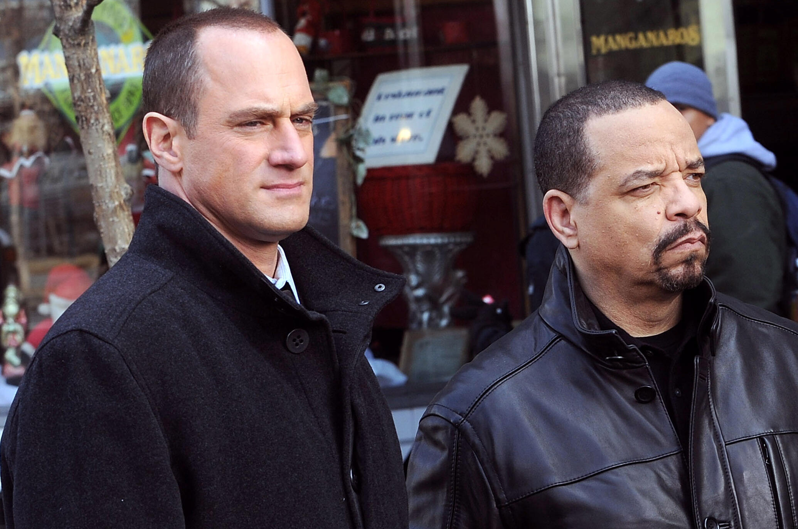

**We're going to see an "evolved"** **Stabler.** During a July appearance *on The Jess Cagle* *Show,* [**Meloni discussed how Stabler will have changed**](https://www.tvguide.com/news/christopher-meloni-elliot-stabler-changed-in-law-order-organized-crime/) since viewers saw him last. "I always thought of Elliot, as flawed as he may have been, I think his heart was always in the right place. I think it was his sense of injustice that just brought out the worst aspects of him. I think age, mellowing — maybe not in his passions, but in how he went about doing his job. He has evolved."

"I think he's going to be coming back into the world — I think as we're all experiencing right now — [the world] has really changed with policing and citizenry," Meloni added. "It's a new day and there are new ways of going about things. I think those are all issues to be addressed in the show and I think it's going to be a challenge for Elliot. One that I think he's going to meet."

**Stabler will return in the *SVU* Season 22 premiere.** *SVU* showrunner [**Warren Leight**](https://www.tvguide.com/celebrities/warren-leight/183309/) revealed on NBC's *SVU* podcast [***The Squadroom***](https://art19.com/shows/the-law-order-svu-podcast/episodes/e455aaeb-2b27-46e3-b43b-c091a927fbc7)that Stabler will first appear in *SVU*'s season premiere before the spin-off debuts. "It's pretty clear that Elliot will be in the *SVU* season opener. I think that much I know," Leight said*.* "Whether we'll get to see his family as well remains to be seen. There's a lot of moving parts. They're launching a new series as well. So it's not just about the *SVU* season opener, it's how do we help launch the new series and how much crossover will there be between Elliot and Olivia as the season goes on." It's unknown *if Organized* *Crime* being pushed to 2021 will impact the plans to have Stabler appear in the *SVU* Season 22 premiere or not.

**Stabler and Benson will explore "unresolved emotions" when they** **reunite.** During an interview with the *New York Post,* [**Meloni shared his expectations**](https://www.tvguide.com/news/christopher-meloni-benson-stabler-reunion-law-order-crossovers/) for the former partners' upcoming reunion. "Benson and Stabler are inextricably linked, locked and connected. I think there is truly and deeply a worthwhile, inherent drama in exploring that relationship and the complexity of how Stabler left — the unresolved emotions both characters feel and how the fans feel," the actor explained.

"I just think there will always be possibilities there," Meloni said of exploring Benson and Stabler's relationship. "People will always be hungry to see how we interact and how that dynamic has changed."

[**21 Seasons In, *Law & Order: SVU* Still Feels as Vital As Ever**](https://www.tvguide.com/news/law-order-svu-season-21-legacy/)

**There will probably be more *SVU* crossovers to come.** Stabler's appearance in the *SVU* premiere will hopefully be the beginning of many crossovers between the long-running procedural and the upcoming spin-off. "It almost feels that we won't do one or two [crossover] episodes and move on our merry way," [**Meloni told**](https://www.tvguide.com/news/christopher-meloni-benson-stabler-reunion-law-order-crossovers/) the *New York Post.*

Although Leight pointed out on *The Squadroom* that there is currently no room for the spin-off on the stages where *SVU* films (which would have made crossovers even easier), both shows are based in NYC, and we can't imagine the producers not taking advantage of every crossover opportunity — especially since they're already doing this so well with One Chicago.

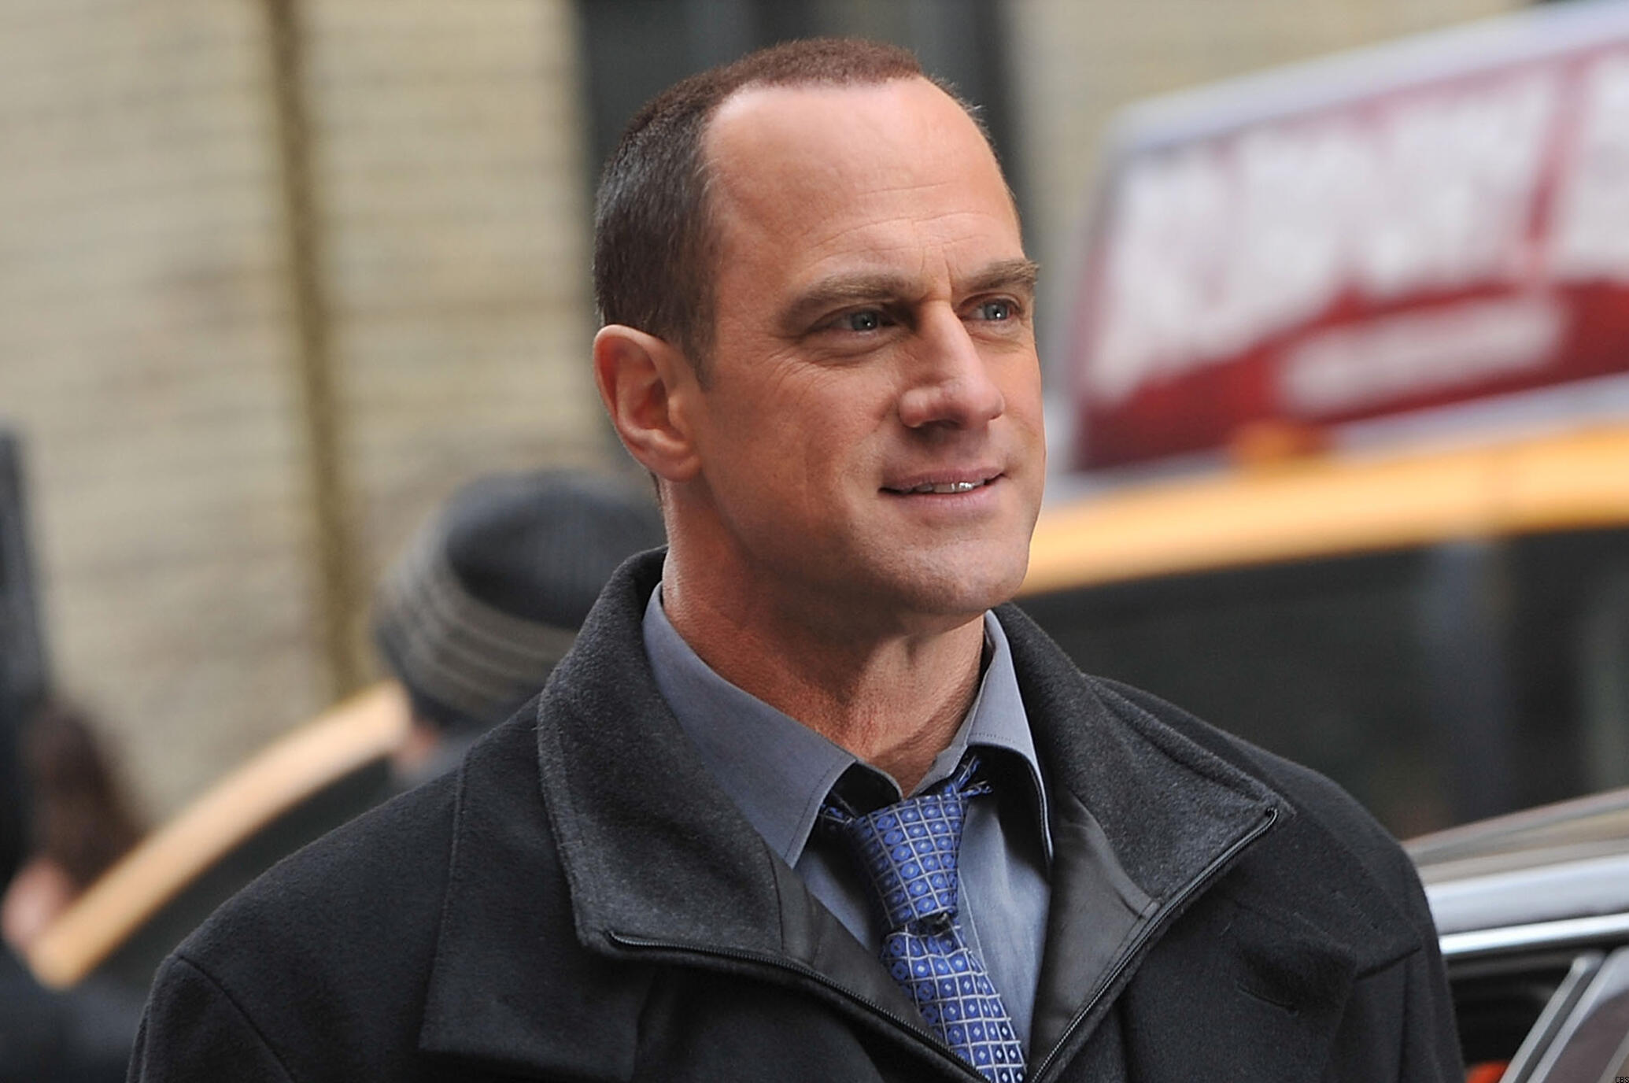

**We'll likely see Stabler's family.** While Leight shared in *The Squadroom* that he isn't sure if Stabler's family will appear alongside him in *SVU*'s Season 22 premiere, we'd be shocked if they didn't make recurring appearances in the spin-off. In fact, Stabler's wife Kathy ([**Isabel Gillies**](https://www.tvguide.com/celebrities/isabel-gillies/154592/)) and one of the couple's two sons, Dickie or Eli, were supposed to return in *SVU*'s Season 21 finale to help set up Stabler's return.

"We had heard distant thunder about Chris Meloni coming back in the fall and we were going to lay a little groundwork for that. We were going to see Kathy Stabler come back very upset. Her son has been rolled by a team of ne'er-do-wells and may have been drugged," Leight said on *The Squadroom*.

[**Paul Wesley, Mark-Paul Gosselaar, and More Recall Their Guest Roles on Law & Order: SVU**](https://www.tvguide.com/news/law-order-svu-anniversary-guest-stars/)

Since Season 21 had to shut down production due to the coronavirus before they filmed the finale, that episode has been scrapped. But family has always been such a big part of who Stabler is that we can't imagine them not being part of the spin-off in some form, even if Stabler's family unit looks a bit different now...

**Stabler's family life may look different.** When Stabler left *SVU*, he was still married to Kathy and raising their five kids: Maureen, Kathleen, Dickie, Elisabeth, and Eli. But when speaking about the scrapped *SVU* finale that would have seen Kathy and one of their sons return, Leight said the episode would have revealed "what had happened to the Stabler family after Elliot both left SVU and apparently left them."

Does that mean that Stabler and Kathy got divorced? Stabler and Kathy did separate in Season 6 before the pair reconciled in Season 8, but we wouldn't be shocked if the couple decided to go their separate ways in the years since. However, there's always the chance Stabler left his family physically as a result of whatever job he took on post-SVU, but that he remained married to Kathy and the dedicated family man he always aimed to be.

Whatever Leight meant, Meloni shared in July that Stabler's [**relationship with his family will have improved**](https://www.tvguide.com/news/christopher-meloni-elliot-stabler-changed-in-law-order-organized-crime/) since we saw him last. "I think he's in a good place now with his family. I think he's in a much better place with himself, vis a vis the world," the actor said on *The Jess Cagle Show.*

*Law & Order: Organized Crime* premieres this fall on NBC. *Law & Order: SVU* is available to stream at [**NBC**](https://www.nbc.com/law-and-order-special-victims-unit/episodes) and [**Hulu**](https://click.linksynergy.com/fs-bin/click?id=Bs9ZhlULz2w&offerid=615841.58&type=3&subid=editorial).

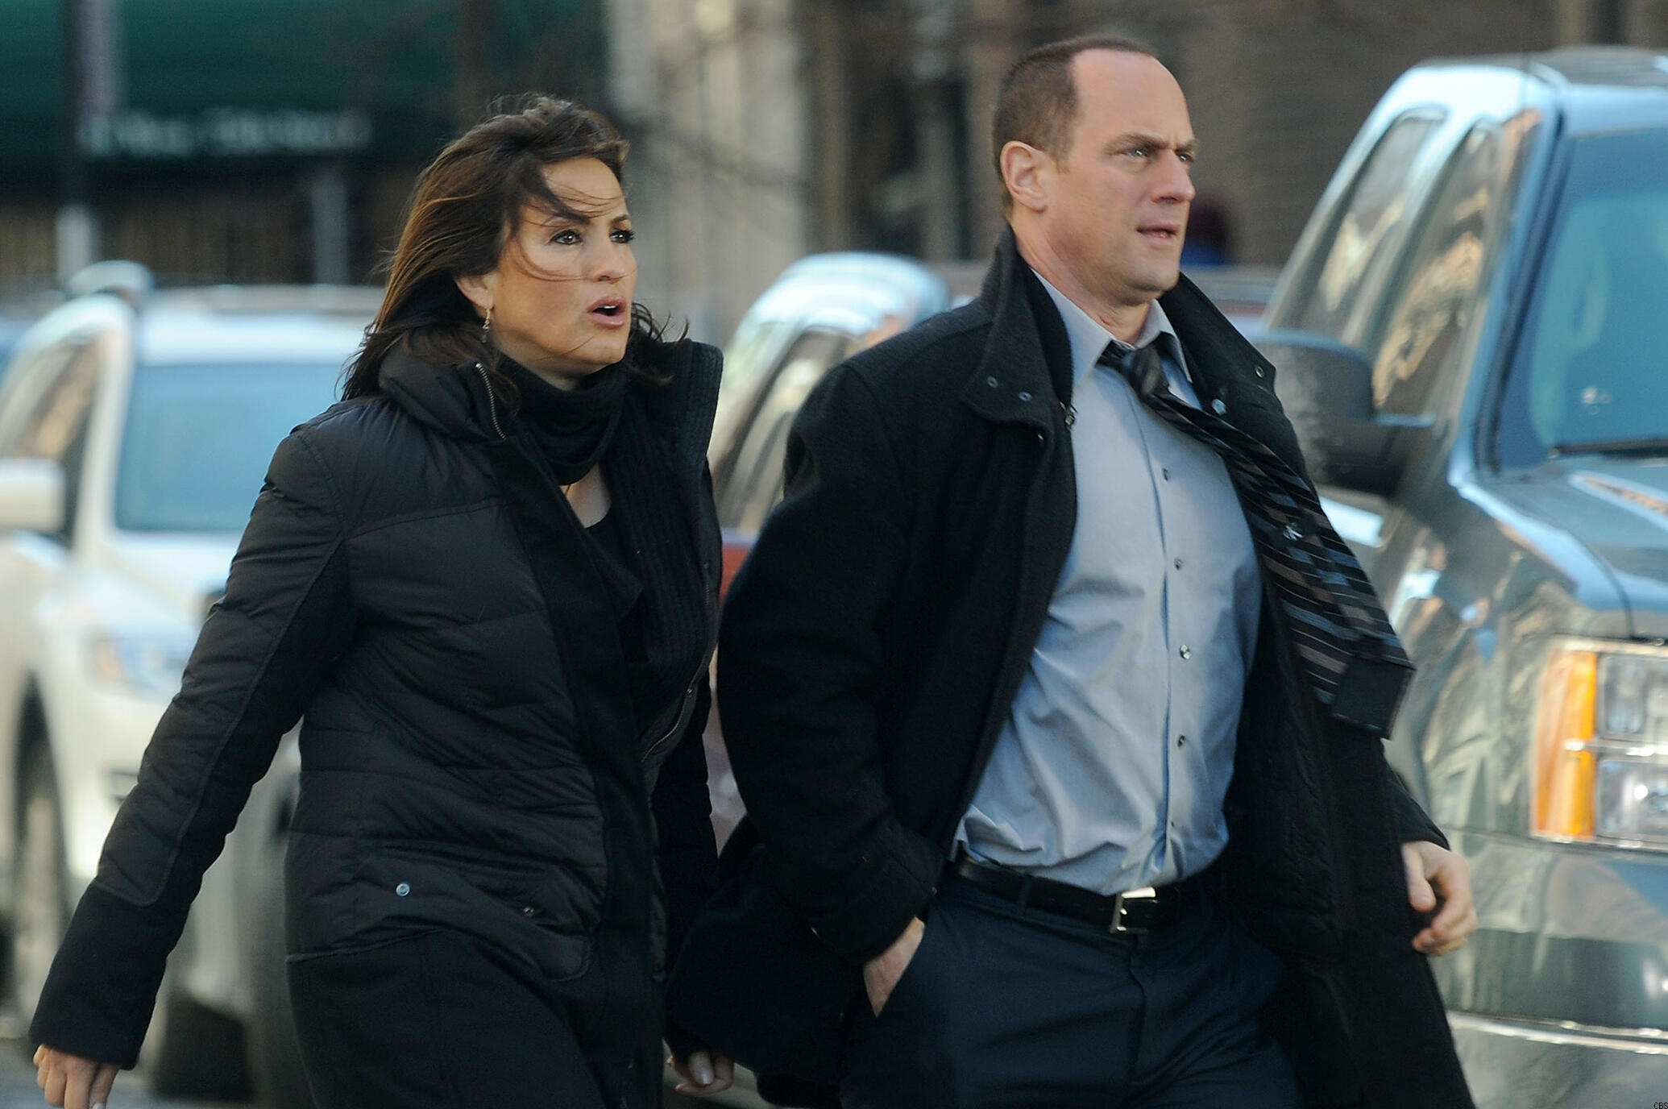

(*Disclosure: TV Guide is owned by CBS Interactive, a division of ViacomCBS.*)